SCRAM Remote Breath®
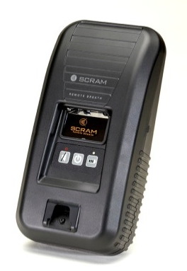
We are pleased to offer the SCRAM Remote Breath® Alcohol Testing Device, a handheld, wireless breath alcohol monitoring device with Automated Facial Intelligence™ (AFI) that provides a GPS location with both taken and missed tests. AFI is the same facial recognition system used internationally by government security forces. It scans and automatically matches the photo of the person taking the test with a baseline photo taken at enrollment.
Data is transmitted from the SCRAM Remote Breath to SCRAMnet, the web-based application managed by AMS where offender data is collected, analyzed, and maintained in a secure, central location. SCRAMnet will notify the supervising authority of any alcohol readings, tamper alerts, or equipment malfunctions so they can respond quickly to problem offenders. This central information hub not only houses all offender data, but allows courts and supervising agencies to access and manage their data from any web-based browser or by using the SCRAMnet Mobile App. In addition, SCRAMnet provides a wide range of “instant” reports—from a snapshot of a single event to a comprehensive view of an offender’s behavior over time.

Key Benefits
- Ethernet connectivity – even if a cellular connection is unavailable, officers can perform installs and offenders can transmit test results
- Automated Facial Intelligence – the same facial recognition system used internationally by government security forces
- The best camera resolution and picture quality in the alcohol testing industry
- Device-initiated testing – automatically turns on and prompts offenders for scheduled and on-demand tests
- Immediate notification of both BrAC and positive offender ID
- Store & Forward – never miss a test
- GPS location with both taken and missed tests
- Rugged – built for corrections
Accuracy: Proven Fuel Cell Technology
The electrochemical fuel cell used in SCRAM Remote Breath has been validated through decades of research and experience. It is considered the gold standard in alcohol testing applications. This is the same fuel cell used in evidential breath testing equipment and interlock devices and is comprised of extremely sensitive and ethanol-specific alcohol sensors.

Automated Facial Intelligence (AFI)
The system uses AFI, the same facial recognition technology used internationally by government security forces. The system automatically scans and confirms each offender’s identity with each breath test to reduce manual matching of photos. AFI technology takes staff time and guesswork out of scrolling through numerous photos, increasing accuracy and efficiency and reducing risk. It allows the agency to focus on dealing with offenders who need the most attention. The benefits include:
- Government security-grade facial recognition software – not just photos.
- Automated matching – reduces manual review of photos by up to 95%, saving a significant amount of staff time.
- Best high-resolution images in the industry – for photos that do need to be reviewed.
- Real-time notifications when offender doesn’t match.
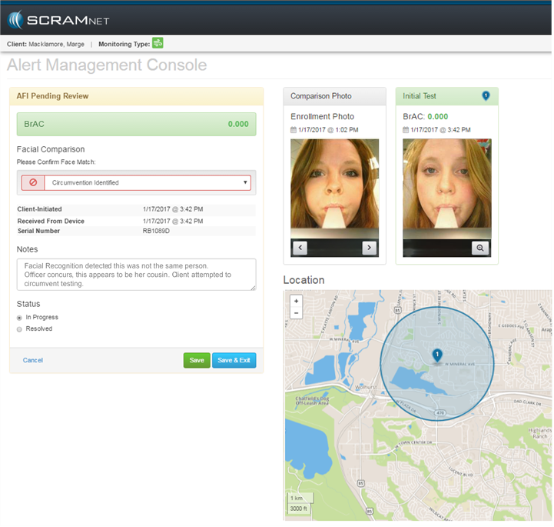
Offenders may have a family member, whom they closely resemble, take their alcohol test in order to pass the visual/photo verification. In this example, AFI identified the circumvention between the two people testing.

Ethernet Connectivity
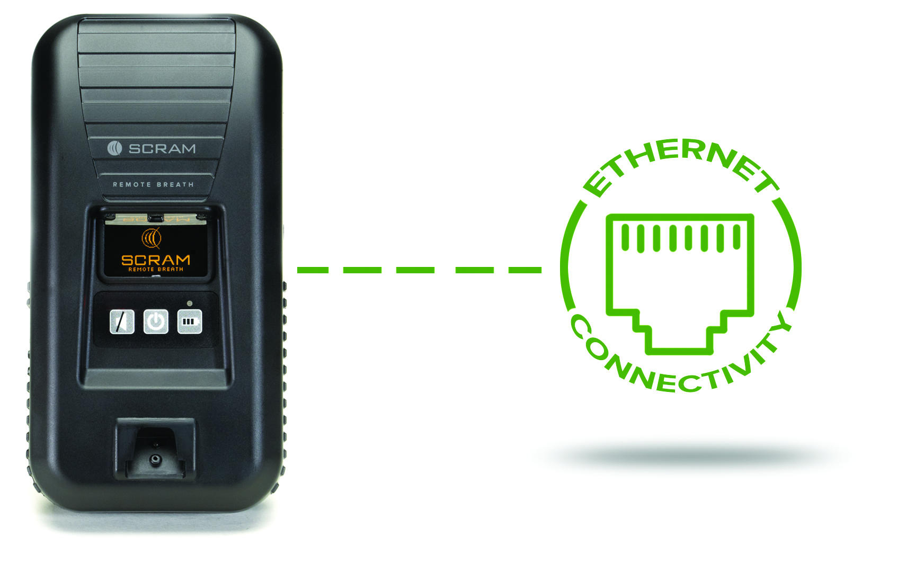
SCRAM Remote Breath was the first mobile breath testing device of its kind with the ability to connect over an Ethernet connection. Offenders who live in areas with no cell coverage can simply plug the device into their home Internet modem to transmit test results. In addition, many agencies perform enrollments in correctional facilities, prisons, jails, and/or detention centers. Because these buildings have limited cellular coverage, enrollments requiring a cellular connection may be difficult. Ethernet capability means that officers can perform an installation anywhere an Internet connection is available.

Offender Feedback
SCRAM Remote Breath also gives feedback to the offender during the enrollment and testing process in order to help ensure quality enrollment and testing photos. This feedback reminds offenders to avoid sitting/not standing straight, direct sunlight, obstructions to the face, or holding the unit at an extreme angle (the breath tube must be level). This functionality allows the user to correct these factors with an immediate retest, resulting in an increased likelihood of a match—saving the agency time and money by reducing the need for officers to manually match photos. Poor tests are corrected in real time with onboard processing. Instructions for a better test are provided to offenders on screen, improving test results with less officer intervention.
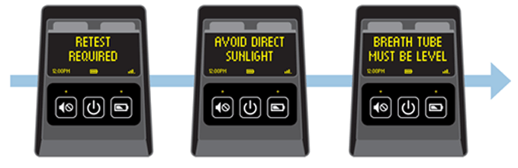
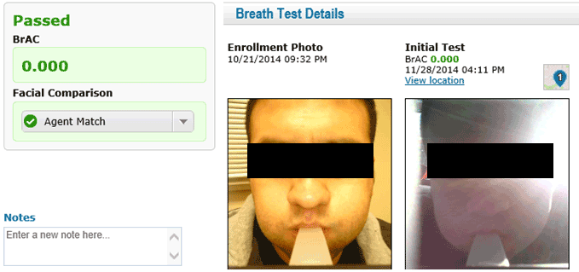

GPS Location with Taken and Missed Tests
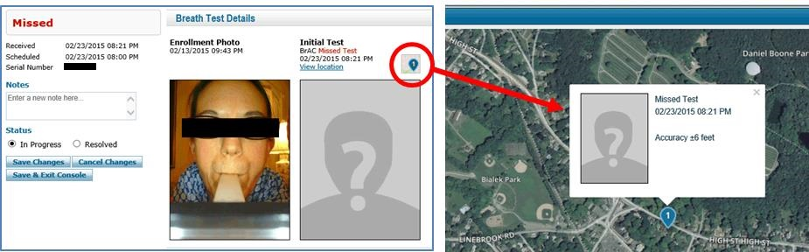
Remote Breath automatically powers itself up during test windows and also tracks its location at the time of the scheduled test. The device is able to provide a GPS location with each and every test—both taken and missed. A GPS location with a missed test is especially useful as it can help an officer make a more informed decision as to why an offender skipped a test. For example, offenders often state they missed a test because they left their device at another location. Officers can verify or refute the offender’s claim by comparing the GPS point on a missed test (verified via GPS ping) with the offender’s location. The following image shows a missed test with the GPS location of the device during that time.

Store & Forward
Some devices rely on cell phone text messages to remind offenders to test, and these devices cannot store test results when in an area without cell coverage. As a result, offenders using these devices may miss tests simply because they’re in an area with poor coverage. SCRAM Remote Breath incorporates a “Store & Forward” feature, which ensures a test prompt is never missed. SCRAM Remote Breath’s industry-leading memory can store up to 48,000 test results when offenders are out of cell range and the device forwards the time-stamped results as soon as coverage is regained.
- With Store & Forward, test schedules are stored when the unit is out of cellular coverage. Results are forwarded when the unit returns to cellular coverage.
- SCRAM Remote Breath automatically turns on and prompts offenders for scheduled and on-demand tests—even when out of cell coverage. Notification for both BrAC and positive offender ID is immediate.

